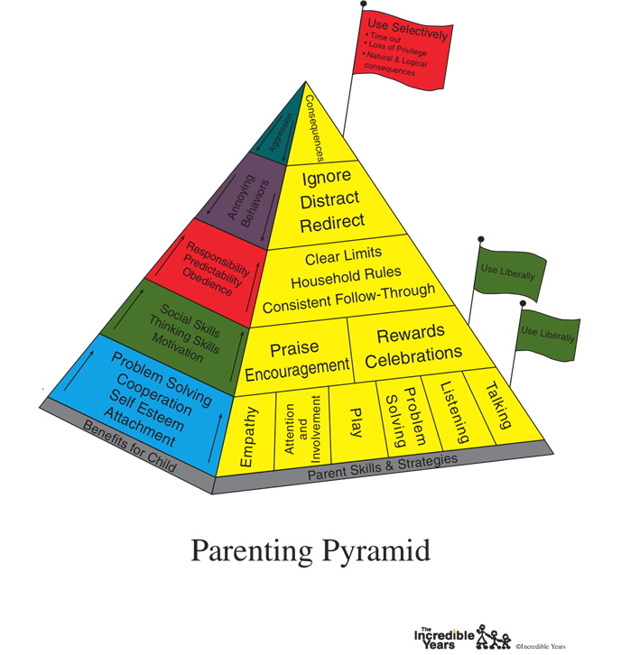**Incredible Years® Preschool/Early Childhood BASIC**

**Authorized Parent Group Leader Training**

**Children’s Hospital Los Angeles**

**October 13, 15, 17 (Mon-Wed-Fri) 2025**

**9 a.m. to 4:30 p.m.**

The Incredible Years® parent group training intervention is a well-established evidence-based behavior management program that promotes parent-child attachment while reducing early onset conduct problems (tantrums, noncompliance, hyperactivity, aggression, and emotion dysregulation). Parents learn to do child-directed play, descriptive commenting, effective praise, and use rewards to promote children's academic, social and emotional competencies and reduce conduct problems. Positive discipline interventions are used to reduce power struggles and effectively support the child in learning more appropriate behaviors. The Parent programs are grouped according to age. This training will be for leaders of the BASIC Preschool/Early Childhood (3-6 years) Program and qualifies the participant to lead the Toddler BASIC (1-3 years) Program and School Age BASIC Parenting (6-8 years) Program.

**Training Details**

**Dates:** October 13, 15, 17, 2025 (Mon-Wed-Fri). Participants must attend all three days to receive a

certificate of authorized training.

**Cost: $795. per participant and includes the Parent Troubleshooting Guide and Collaborating with Parent books by Developer Carolyn Webster-Stratton, PhD.**

**Place:** CHLA Behavioral Health Institute, 3250 Wilshire Blvd., Suite 600, Education & Training Center Room 623,

Los Angeles, CA 90010

**Time:** 9 a.m. to 4:30 p.m. (Lunch on your own)

**Transportation:** Conveniently located one block from the Wilshire/Vermont Metro Red/Purple Line Station

**Parking:** Entry on New Hampshire side of building. Please note that CHLA does not provide validation for parking.

Please email completed form to:

**Dean M. Coffey, Psy.D.**| Clinical Associate Professor of Clinical Pediatrics (Clinician Educator)

Program Area Lead, Child & Family Mental Health

USC University Center for Excellence in Developmental Disabilities

Children's Hospital Los Angeles

4650 Sunset Blvd., Mailstop #53|Los Angeles, CA 90027

Ph: 323.361.7741|Fax: 323.361.8342| [dcoffey@chla.usc.edu](mailto:dcoffey@chla.usc.edu)

REGISTRATION FORM – please print clearly

**Name**______________________________________________

**Home address:**

Street_________________________________

City________________________ State_____________ Zip____________

**Work address:**

Street__________________________________

City_____________________ State___________ Zip_____________

Phone: Cell: ___________________ Work: ________________________

Email: _______________________________ Fax: ________________________

Position/Title__­­­­­­­___________________ Agency: __________________________

Highest degree:­­­______________________

**Professional Education (or title) in Organization (Mark all that apply):**

___ a. Special needs education (special education)

___ b. Psychologist

___ c. Social work/Social care/Mental Health Counselor

___ d. Child educational therapist

___ e. Nurse

___ f. Teacher

___ g. School Psychologist/Counselor

___ h. Psychiatrist/Physician

___ i. Administration

___ j. Health Visitor

___ k. Nursery Nurse

___ l. Family Support/Family Advocacy Worker/Liaison

___ m. Learning Mentor

___ n. Educational welfare

___ o. Early childhood educator

___ p. Parent/Community/Health Educator

___ q. Other (specify) ____Allied Health (Physical Therapy)

Ages of children you will be using IY Programs with: 0-2 yrs ____ 2-3 yrs ____ 4-5 yrs _____ 6-8 yrs ______ 9-12 yrs ______